Massachusetts Non Profit Network

November 1, 2017

Resource and Workbook



November 1, 2017

Welcome!

I am the Founder and President of Social Profit Ventures, a boutique organizational development firm that forges partnerships with executives and their leadership teams, designs and executes successful strategic planning and fundraising strategies, and delivers an expansive array of leadership coaching, skill trainings, and interactive learning opportunities.

I am delighted that you have chosen to join me for this interactive session entitled, “Greater Institutional Abundance Through Effective Relationship Building.” Throughout my 25 years in philanthropy, first as a practitioner, and now as a consultant, I have a deep appreciation for the power of positive language and mindset as a requisite for cultivating a robust development practice.

Therefore, when thinking about generating greater resources to fuel the noble work and impact of nonprofits, I am inspired by the promise and imperative of creating even greater Institutional Abundance.

What does this mean to you?

I am excited to learn with you through this session where we will first explore the stages of a robust major donor relationship program, which include: sourcing (pipeline development), qualification, cultivation, solicitation, and stewardship. We will then engage in a variety of facilitated exercises to build your proficiency in all these stages, paying special attention to the flair and finesse you will bring to solicitations. You will walk away from this experience with tangible skills that will not only enable you to develop powerful individualized donor development plans for each of your prospects, but also expand your creativity in the way in which you raise vital dollars and long-term relationships on behalf of your organization.

Thank you again for joining me on this exciting journey. Please stay in touch by both taking advantage of a free 30-minute consulting session on ways to maximize your organization’s fundraising potential, and joining my Social Profit Ventures Network.

With admiration and appreciation,

Andrea B. Wasserman

Founder and President, Social Profit Ventures

Table of Contents

1. Exercise One:

Institutional Abundance - In a Word Page 4

1. Exercise Two:

Connection Among Passion, Mission, and Need Page 5

1. Resource:

Relationship Cycle Page 6

1. Resource:

“ABC’s of Donor Prospecting,” Iris Sutcliffe Page 7 -9

1. Exercise Three:

New Way of Looking at Donor Pyramid Page 10

1. Resource:

Prospect Research at Your Fingertips Page 11

1. Resource:

Components of Moves Management Program Page 12

1. Exercise Four:

Cultivation Strategies That Inspire Page 13

1. Resource:

Anatomy of a Solicitation Page 14

1. Exercise Five:

Personal Solicitation Pop Quiz Page 15-16

1. Post Workshop Exercise Six:

Practice Page 17

Exercise One:

Institutional Abundance - In a Word

As you think about the aspirational vision of your nonprofit, please consider and share in a word, what the term **Institutional Abundance** represents to you

Exercise Two:

Connection Among Passion, Mission, and Need

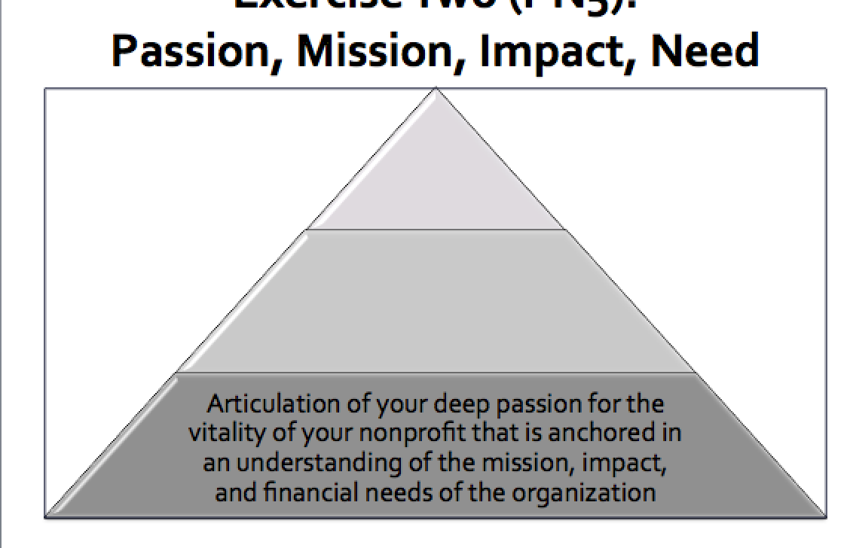

Resource:

Relationship Cycle

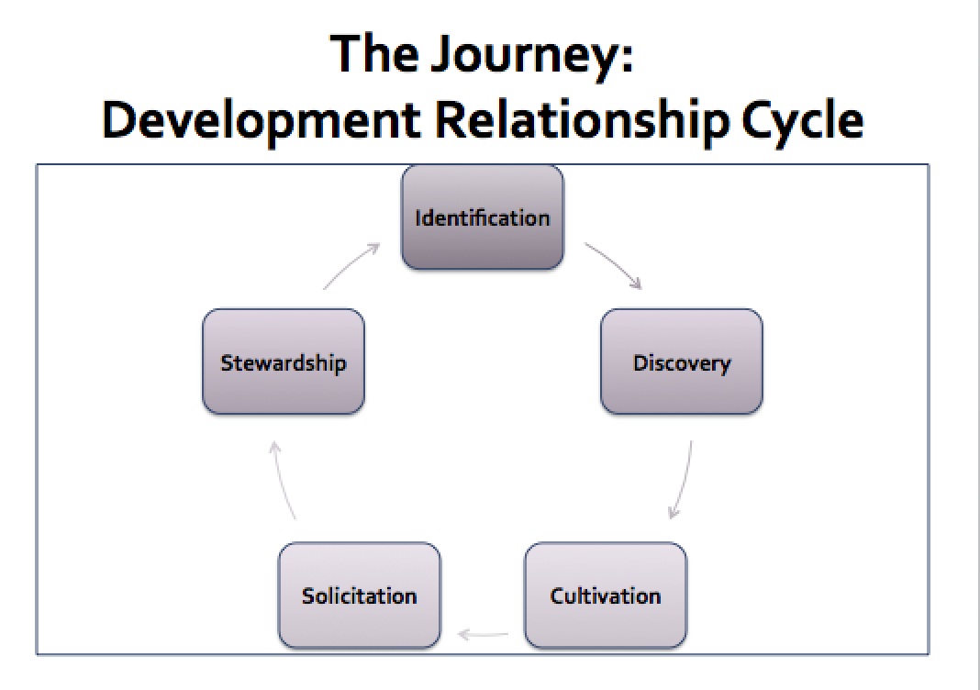

Resource:

ABC’s of Donor Prospecting

The ABCs of Donor Prospecting

by Iris Sutcliffe

March 27, 2015

www.networkforgood.com/nonprofitblog/abcs-donor-prospecting

Virtually every nonprofit has high-capacity donors hiding in plain sight. A whopping 40% of donors in a recent study admitted they could give more than they currently are. Our job as fundraisers is to identify those prospects so we can start moving them up to greater levels of giving. Here’s how to start making that happen.

**The Myth of the Donor Pyramid**

First, let’s talk about the donor pyramid—what we think it looks like, what it really looks like, and the opportunities it holds for your nonprofit.

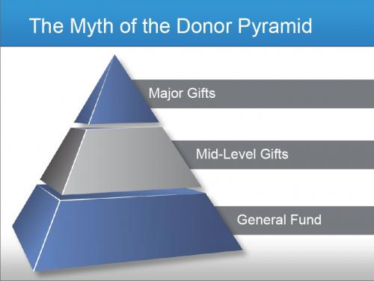

*We think our donor list is a pyramid.*

You’ve probably seen the donor pyramid a million times and think your donor files look like this: a strong base of general fund donors, a solid but somewhat smaller core of mid-level gifts, and a few major donors on top. What we’ve learned, however, is that the pyramid isn’t really a pyramid at all. In reality, it looks more like a sombrero: many people giving small amounts and a few people giving large amounts, with very few mid-level donors.

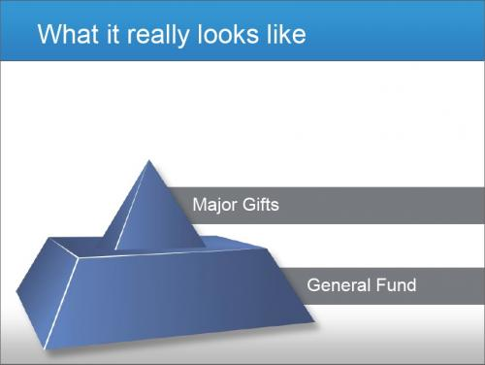

*Most donor lists more closely resembles a sombrero rather than a pyramid.*

This missing middle isn’t because of our donors’ behavior. It’s because of ours. We have prospects for every level hiding in our general fund, but most nonprofits don’t have an intentional mid-level strategy. These folks need to be identified, given more love and attention, and encouraged to move up to mid-level and eventually, major gifts.

**Who Are Your Mid-Level Donors?**

Mid-level donors are sort of like the forgotten middle child—the “Jan Brady” of donors. They might look like low-level givers. They could be volunteers or have attended your events. They’ve probably engaged with you but just haven’t made a gift. Thing is, these prospects are very likely to give on the first ask—but they need personalized attention to get there.

Most major donors actually begin at the bottom of the pyramid. Annual fund donors are strong prospects for moving up to mid-level giving. These are your future major donors, so it’s worth investing your time and resources in moving them up.

**What’s Your Favorite Strategy to Find More Donors?**

* Direct mail and/or online acquisition campaign
* Staff and board brainstorm names of prospects
* Prospect research
* All (or some) of the above

A combination of these is the most popular strategy, closely followed by brainstorming names. Brainstorming sounds like a great plan, but it can become derailed by magical thinking—“If we only had this particular mega-millionaire donating to us”—while you overlook great prospects already in your own backyard.

**ABCs of Identifying Prospects**

There are opportunity costs associated with cultivating donors in terms of time and money, and we have an obligation to be good stewards of our nonprofit’s resources. This means learning the ABCs of prospecting:

* **Access:** People we already know or with whom we share a solid connection.
* **Belief:** People who share similar interests or already believe in our mission.
* **Capacity:** People with the ability to move up the giving pyramid.

Effective prospecting begins with Access—prospects we already know. Unfortunately, we often skip ahead to Capacity and start with who’s rich. And that’s where we get into trouble. Capacity does not equal interest (Belief), nor does it equal generosity.

If you don’t have Access to a big donor, or if the big donor doesn’t already have interest or Belief in your mission, despite their Capacity, pursuing them may come at the expense of missing the “millionaires next door” already in your files.

**Prospecting Tips for Greater Giving**

Here are some final points to consider when identifying and cultivating general fund donors to move up to the next level of giving:

**Longevity:** How long has the donor been in your files? Long-term giving could mean moving a donor into planned, recurring, or major gifts.

**Cumulative giving:** Be sure to look at cumulative giving, not just the amount they give each year. A donor who gives $2,500 four times year tends to be more receptive than one who gives an annual lump sum of $10,000.

**Engagement:** This is huge. Are they volunteering? Are they reading your emails and newsletters? How involved are they in your organization? People who are investing time in your nonprofit are great candidates for moving up the pyramid.

**Referrals:** People who were referred to your organization by another donor, especially major donors, meet the Access requirement right off the mark.

**Remember:** Donors give for their reasons, not ours. For greater success, start with the folks you already know.

*Adapted from Network for Good’s Nonprofit 911 webinar “*Find High-Capacity Donors Hiding in Plain Sight*,” with Rachel Muir, founder of Girlstart and vice president of training at Pursuant.*

Exercise Three:

New Way of Looking at the Donor Pyramid

Where are your best major donor prospects likely to come from?

Resource:

Prospect Research at Your Fingertips

Discovery

The “Discovery Process” is understood to be the collection of the activities and actions—electronic research, peer screening research, phone calls, letters, emails, and visits—taken to initially qualify a prospect as a potential major prospect.



Resource:

Components of Moves Management Program

As David Dunlop, creator of the system, described it, “The moves concept focuses major gift fundraising on changing people's attitudes so they want to give. To do this, we take a series of initiatives or moves to develop each prospect's awareness of, knowledge of, interest in, involvement with, and commitment to the institution and its mission.”

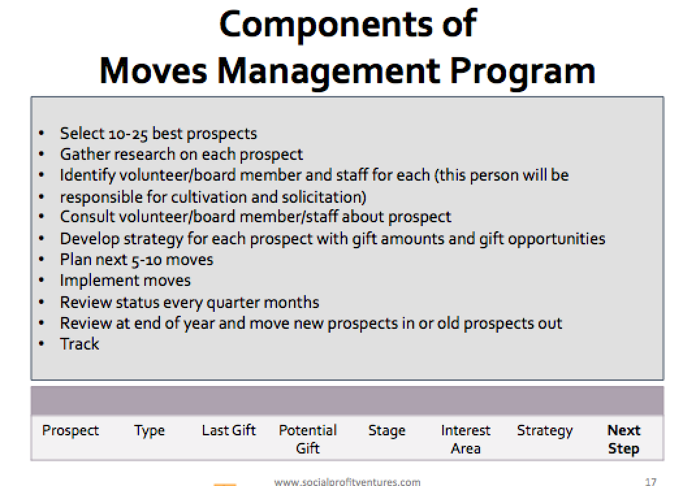

Exercise Four:

Cultivation Strategies That Inspire

**Cultivating** prospects through personal outreach and donor-centered strategies that involve appropriate staff and volunteers and incorporate what you have learned about a prospect.

Please think about a prospect or two that have been activated.

Drawing upon what we learned thus far, what tools/resources do you have to not only educate, but also inspire your prospects according to his/her interests?

Resource:

Anatomy of a Solicitation

Solicitation

*Soliciting gifts for specific amounts that reflect the cultivation strategy and represent personally significant or stretch commitments.*

Your prospect has been identified, research done, interests determined, and a cultivation process has led you to the moment of fundraising truth.

It’s time to ask for the gift. It’s not hard; in fact it’s rather easy when you think about it. By now you know your prospect and he or she knows you. A relationship has been established.

So what’s your next move?

Exercise Five:

Personal Solicitation Pop Quiz

1. Prep
   * Who should be invited to the meeting?
2. Land the Meeting
   * What is the best locale for the meeting?
3. Opening
   * What are the best ways for you to establish a rapport and prime this conversation for success?
4. The Case
   * Engage first, then educate prospect about organization from his/her perspective
     + - Translate this into real action
5. The Ask
   * Define the amount that you are asking for
     + - After you ask your prospect to consider a gift of $x,000, what is your next move?
6. The Negotiation
   * How would you respond to resistance – “I’m not ready to make a commitment now?”
7. The Close
   * When is the right time to close the conversation?
8. Post Meeting
   * You have secured the gift, now what?

Post Workshop Exercise Six:

Practice

1. Prepare:
   * + Think about your donor’s motivations and interests and how you can help him/her to succeed at philanthropy.
     + How will you talk to you donor about the mission? Where would he/she see greatest value proposition?
     + Be prepared for objections. Imagine the issues the donor might raise and come up with appropriate answers.
2. Give your partner the profile of the donor or prospect you have chosen.
3. Employ your methodology and role-play with your partner.
4. Freeze; give feedback. Switch; repeat.

