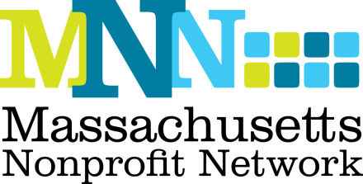

**Spring 2017 Communications Intern**

**Summary:**

The Massachusetts Nonprofit Network (MNN) is the voice of the nonprofit sector in Massachusetts and understands that strong nonprofits build strong communities. MNN is the only statewide organization dedicated to supporting the nonprofit sector through advocacy, public awareness, and capacity building. MNN includes more than 750 member organizations, representing every part of Massachusetts—from the Berkshires to the Cape.

MNN is seeking a Communications Intern to support our efforts to: strengthen the organization’s brand; recruit, retain, and engage MNN members; and increase public awareness of the nonprofit sector as efficient, effective, and essential. This is a great opportunity to develop a strong understanding of the nonprofit sector in Massachusetts, expand on communications skills, and experience working in a small, friendly organization. The Communications Intern is a part-time position with a flexible schedule.

**Location:**

* 89 South Street, Suite 603, Boston, MA 02111 (one block from South Station)

**Reports To:**

* Communications Manager

**Responsibilities:**

* Work closely with the Communications Manager to expand and enhance the organization’s brand
* Assist the Communications Manager with all aspects of outreach to MNN’s members, nonprofit and business leaders, and the media
* Compile the organization’s bi-weekly electronic newsletter
* Copywriting for press releases, electronic alerts, memos, and other materials
* Support MNN’s day-to-day social media outreach
* Opportunity to contribute “long-form” articles for the bi-weekly bulletin on topics of interest to the nonprofit sector
* Research topics of importance for use in opinion pieces, talking points, etc.
* Perform related responsibilities and tasks as assigned

**Preferred Qualifications:**

* Pursuing bachelor’s degree or recent college graduate
* Excellent writing skills
* Demonstrated research skills
* Strong interpersonal skills
* Experience with Microsoft Office
* Strong work ethic and desire to “get the job done”
* Ability to prioritize and manage multiple projects and deadlines
* Attention to detail

**Benefits:**

* Stipend available
* Flexible schedule (within normal business hours)
* School holidays and vacations will be respected

**Application Instructions:**

To apply, please email your resume and a cover letter detailing your interest in the position and relevant skills/experience to [info@massnonprofitnet.org](mailto:info@massnonprofitnet.org).

If you have any questions, please contact Natasha Terhorst at (617) 330-1188 ext. 285 or [nterhorst@massnonprofitnet.org](mailto:nterhorst@massnonprofitnet.org).