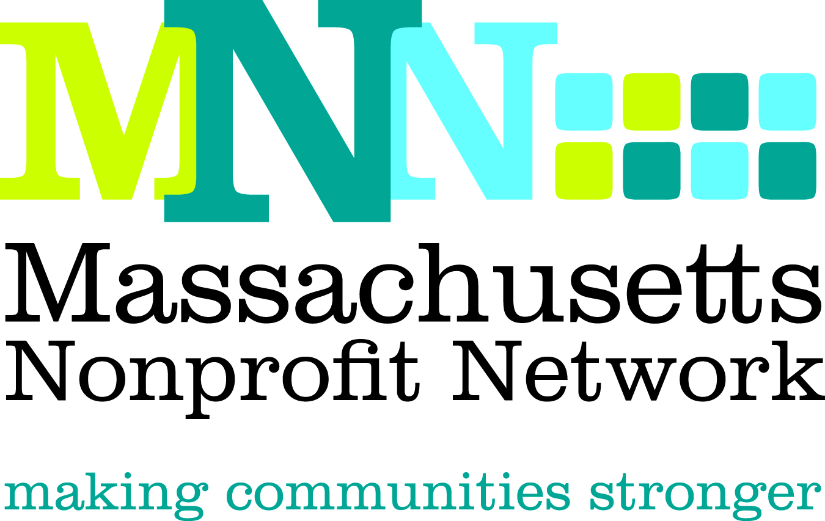

2015 Excellence Award Nomination
Collaboration: Collective Impact

The Excellence Award in Collaboration recognizes the lead organization that was the catalyst for an effort by two or more nonprofit organizations that partnered to address a compelling problem that could not have been solved as effectively by the individual organization(s).

Please be as specific as possible when completing the nomination and be sure to highlight why the nominee is uniquely qualified for this award. Nominations will effectively convey the following criteria about how the organization(s):

- Identified a clear and compelling need in the local community/nonprofit sector
- Identified an approach, and appropriate partners, to respond to the need by working collaboratively
- Worked with their partner(s) to meet the need by defining roles, effectively allocating combined resources, utilizing efficient communication, and implementing a clear process for accountability
- Achieved meaningful and measureable outcomes that were made possible through collaborative efforts

Deadline: The deadline for all nominations is Tuesday, March 10. 2014.

Submission Instructions:

Nominations must be submitted through our online form by March 10, 2014. Please visit www.massnonprofitnet.org/nominate to submit your nomination.

Online submission progress can be saved and resumed later. For your convenience, the nomination questions are also listed on the next page.

Additional Information:
Refer to the Excellence Award FAQ page on the MNN website for more information about Nonprofit Awareness Day and the Excellence Award judging process.

Questions:
Please contact Emily Tamanaha at etamanaha@massnonprofitnet.org or 617-330-1188x281.
Collaboration Excellence Award Nomination Form

**Please prepare the questions below and complete the online nomination form at www.massnonprofitnet.org/nominate**

- Nominee Information:
Organization:

- Provide a brief overview of the lead organization, including mission, approximate size and date established, programs and services offered, and populations served, as well as relevant information about the collaborating organizations. (150 word limit)

- What was the nominee’s goal and how did it address a clear and compelling need? (200 word limit)

- Explain how the nominee identified an approach and appropriate partners to respond to the need. Specifically cite why the nominee believed this collaborative approach was more effective than working alone. (200 word limit)

- Describe how the nominee worked with their partner(s) to meet the need. Use specific examples of how the nominee and partner(s) effectively defined roles, allocated combined resources, utilized efficient communication, and implemented a clear process for accountability. (200 word limit)

- Provide a clear description of how the nominee achieved meaningful and measureable outcomes that were made possible through collaborative efforts. Please be as specific as possible. (200 word limit)

- Nominee Contact Information:
Name:
Title:
Organization:
Email Address:
Phone Number:

- Nominator Contact Information: (Please leave blank if self-nominating.)
Name:
Email Address:
Phone Number:

