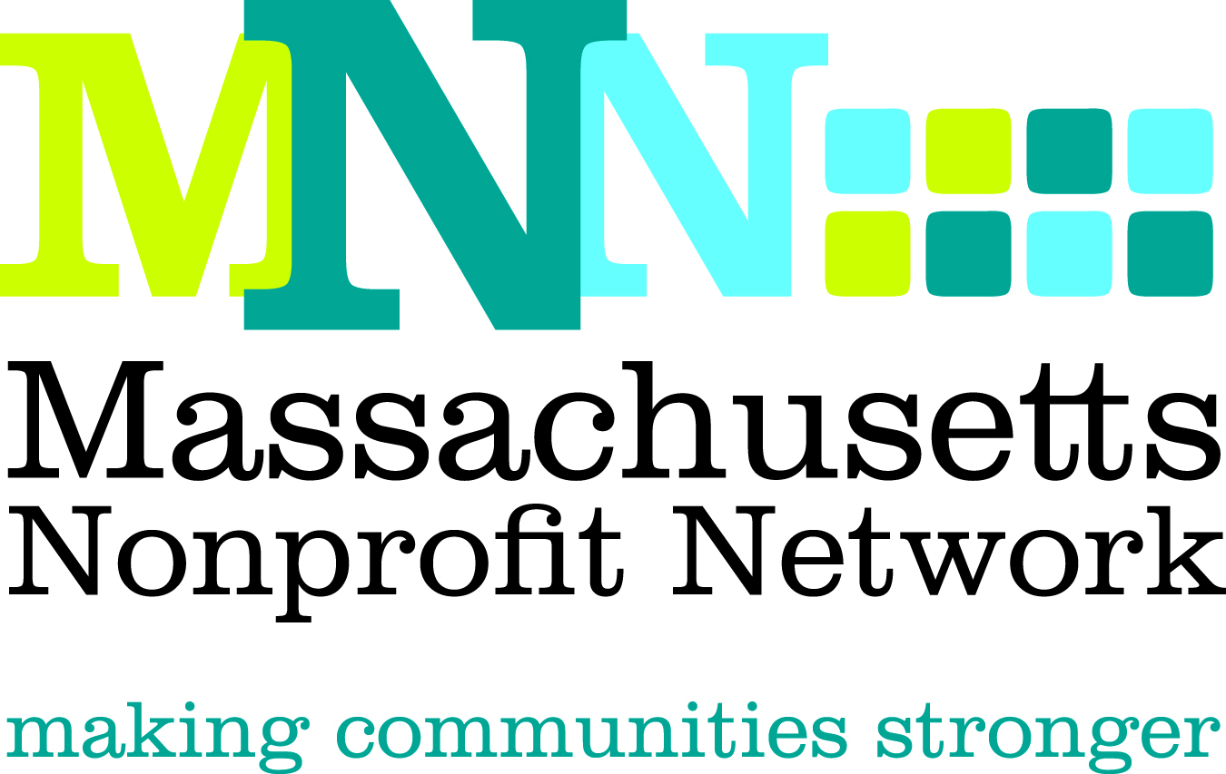

2014 Excellence Award Nomination
Communication: Telling Your Story

The Excellence Award in Communication recognizes a nonprofit organization that has effectively strengthened the organization through clear and strategic messaging, channels, tools and tactics, and through identification of and outreach to target audiences, in order to expand resources to the population served.

Nominations will effectively convey the following criteria about how the organization:

- Developed a response to a clear and compelling organizational need through strategic communication
- Created clear, compelling, and creative message(s) and materials
- Developed a comprehensive and coherent plan with clear goals
- Effectively identified and utilized channels, tools and tactics to engage target audiences
- Achieved meaningful and measureable outcomes

Deadline: The deadline for all nominations is March 4, 2014

Submission Instructions:

Nominations must be submitted through our online form by March 4th, 2014. Please visit www.massnonprofitnet.org/nominate to submit your nomination.

Online submission progress can be saved and resumed later. For your convenience, the nomination questions are also listed on the next page.

Additional Information:
Refer to the Excellence Award FAQ page on the MNN website for more information about Nonprofit Awareness Day and the Excellence Award judging process.

Questions:
Please contact Emily Tamanaha at etamanaha@massnonprofitnet.org or 617-330-1188x281.
Communication Excellence Award Nomination Form

**Please prepare the questions below and complete the online nomination form at www.massnonprofitnet.org/nominate**

- Nominee Information:
Name:
Title:
Organization:

- Provide a brief overview of the organization, including mission, approximate size and date established, programs and services offered, and populations served. (200 word limit)

- Describe the need or challenge addressed and the message, plan, channels, tools and tactics used to address this issue. Please be as specific as possible. (200 word limit)

- With the above criteria in mind, describe why the communications strategy this organization has utilized would qualify them for this award. Please use specific examples. (200 word limit)

- Provide a clear description of the outcomes achieved in this area and how the actions described above led to these outcomes. Please be as specific as possible. (200 word limit)

- Nominee Contact Information:
Name:
Email Address:
Phone Number:

- Nominator Contact Information: (Please leave blank if self-nominating.)
Name:
Email Address:
Phone Number:

