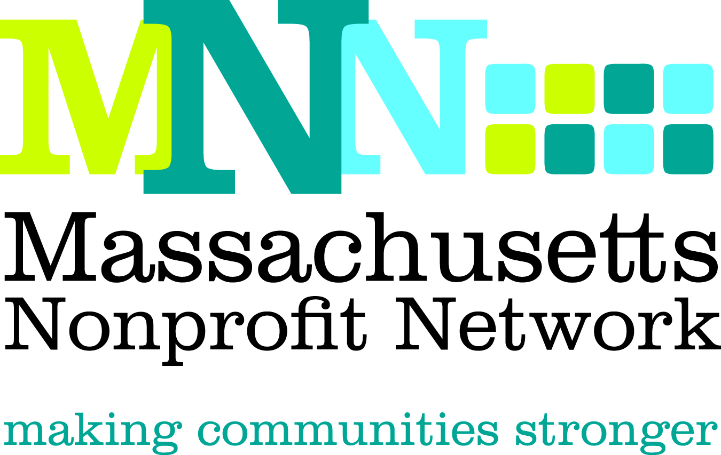

2014 Excellence Award Nomination
Collaboration: Collective Impact

The Excellence Award in Collaboration recognizes the lead organization who was the catalyst for an effort by two or more nonprofit organizations that partnered to address a compelling problem that could not have been solved as effectively by the individual organization(s).

Nominations will effectively convey the following criteria about how the collaboration:

- Identified an approach to respond to a pressing need which could be better addressed by working collaboratively
- Achieved goals through effective communication, information sharing, clearly defined roles for participating organizations, and a clear process for accountability
- Demonstrated effective allocation and use of combined resources in a way that furthered the missions of all involved organizations
- Achieved meaningful and measureable outcomes that were made possible through collaborative efforts

Deadline: The deadline for all nominations is March 4. 2014.

Submission Instructions:

Nominations must be submitted through our online form by March 4th, 2014. Please visit www.massnonprofitnet.org/nominate to submit your nomination.

Online submission progress can be saved and resumed later. For your convenience, the nomination questions are also listed on the next page.

Additional Information:
Refer to the Excellence Award FAQ page on the MNN website for more information about Nonprofit Awareness Day and the Excellence Award judging process.

Questions:
Please contact Emily Tamanaha at etamanaha@massnonprofitnet.org or 617-330-1188x281.
Collaboration Excellence Award Nomination Form

**Please prepare the questions below and complete the online nomination form at www.massnonprofitnet.org/nominate**

- Nominee Information:
Name:
Title:
Organization:

- Provide a brief overview of the lead organization, including mission, approximate size and date established, programs and services offered, and populations served, as well as relevant information about the collaborating organizations. (200 word limit)

- Briefly describe the target need or issue identified and the steps taken through the collaborative efforts to address the need or issue. (200 word limit)

- With the above criteria in mind, describe why this collaborative effort would qualify them for this award. Please use specific examples. (200 word limit)

- Provide a clear description of the outcomes achieved in this area and how the actions described above led to these outcomes. Please be as specific as possible. (200 word limit)

- Nominee Contact Information:
Name:
Email Address:
Phone Number:

- Nominator Contact Information: (Please leave blank if self-nominating.)
Name:
Email Address:
Phone Number:

