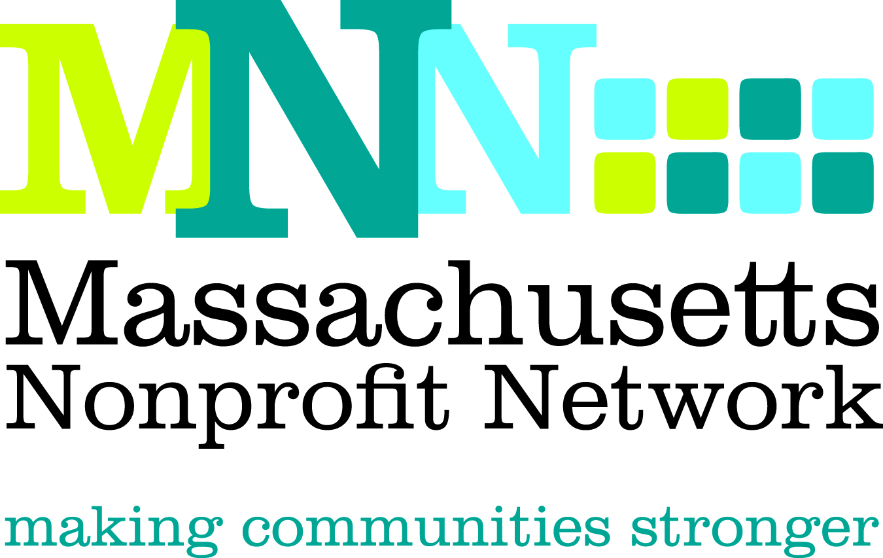

2014 Excellence Award Nomination
Advocacy: Changing the Game

The Excellence Award in Advocacy recognizes a nonprofit organization whose work has recently affected significant public policy change through the education and mobilization of constituents, the general public, and/or public policy decision makers.

Nominations will effectively convey the following criteria about how the organization:

- Instituted an effective strategy with an achievable goal to address a clear and compelling need
- Created and implemented an effective and timely campaign to achieve goal
- Engaged constituents, the general public, and/or public policy decision makers in a meaningful way throughout the advocacy process
- Used effective communication and outreach messages and tools
- Achieved meaningful and measurable outcomes

Deadline: The deadline for all nominations is March 4, 2014

Submission Instructions:

Nominations must be submitted through our online form by March 4th, 2014. Please visit www.massnonprofitnet.org/nominate to submit your nomination.

Online submission progress can be saved and resumed later. For your convenience, the nomination questions are also listed on the next page.

Additional Information:
Refer to the Excellence Award FAQ page on the MNN website for more information about Nonprofit Awareness Day and the Excellence Award judging process.

Questions:
Please contact Emily Tamanaha at etamanaha@massnonprofitnet.org or 617-330-1188x281.

Advocacy Excellence Award Nomination Form

**Please prepare the questions below and complete the online nomination form at www.massnonprofitnet.org/nominate**

- Nominee Information:
Name:
Title:
Organization:

- Provide a brief overview of the organization, including mission, approximate size and date established, programs and services offered, and population served. (200 word limit)

- Briefly explain the need or issue the campaign addressed, its goal, and the strategies used to achieve the goal. Please use specific, concrete examples. (200 word limit)

- Describe the messages and tools used to recruit and engage supporters in the campaign and to reach the public policy decision makers to garner their support for the goal. Please use specific, concrete examples. (200 word limit)

- Provide a clear description of the outcomes achieved by this effort and how the actions described above led to these outcomes. Please be as specific as possible. (200 word limit)

- Briefly describe why this organization is uniquely qualified for this award. (150 word limit)

- Nominee Contact Information:
Name:
Email Address:
Phone Number:

- Nominator Contact Information: (Please leave blank if self-nominating.)
Name:
Email Address:
Phone Number:

