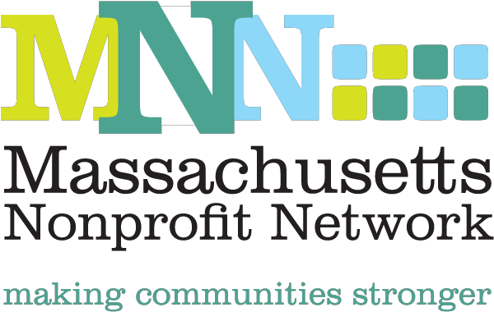

**Communications Associate:**

**Description:**

The Massachusetts Nonprofit Network is the voice of the nonprofit sector in Massachusetts and understands that strong nonprofit organizations build strong communities.  MNN is the only statewide organization dedicated to supporting nonprofits through policy, awareness and capacity building strategies. MNN includes nearly 500 member organizations, representing every part of Massachusetts—from the Berkshires to the Cape. MNN is seeking a Communications Associate intern to support our work to attract, retain and engage MNN members throughout Massachusetts, through a range of activities, including maintaining accurate and up to date information, member communications, and implementing events and meetings. This is an opportunity to learn more about the nonprofit community in Massachusetts, develop new skills and hone existing ones, and to experience working in a small but friendly nonprofit organization.

**Location:**

* 89 South Street, Suite 603, Boston, MA 02111 (One block from South Station)

**Duties:**

* Assist the Communications Director with all aspects of outreach and communication to MNN’s members, nonprofit leaders, and the general public.
* Responsible for the compilation of the organization’s bi-weekly electronic newsletter
* Copywriting for press releases, electronic alerts, memos, and materials
* Support MNN’s day-to-day social media outreach
* Opportunity to contribute ‘long-form’ articles for the bi-weekly bulletin on topics of interest to the sector
* Research topics of importance for use in opinion pieces, talking points, etc.
* Perform related duties and responsibilities as assigned

**Preferred Qualifications:**

* Pursuing Bachelors Degree or recent college graduate
* Excellent writing skills are required
* Proven research skills
* Entrepreneurial, self-starter who can prioritize and manage projects and deadlines
* Proficiency with Microsoft Office Suite
* Attention to detail
* Strong interpersonal skills

**Details & Benefits:**

* **Monthly T Link Pass provided**.
* Unpaid internship. Start date is negotiable.
* Minimum of 15 hours per week.
* Flexible schedule available during normal business hours.
* School holidays and vacations will be respected.

**Contact:**

* Kaitlin Henry: (617) 330-1188 ext. 285 or [khenry@massnonprofitnet.org](mailto:khenry@massnonprofitnet.org)