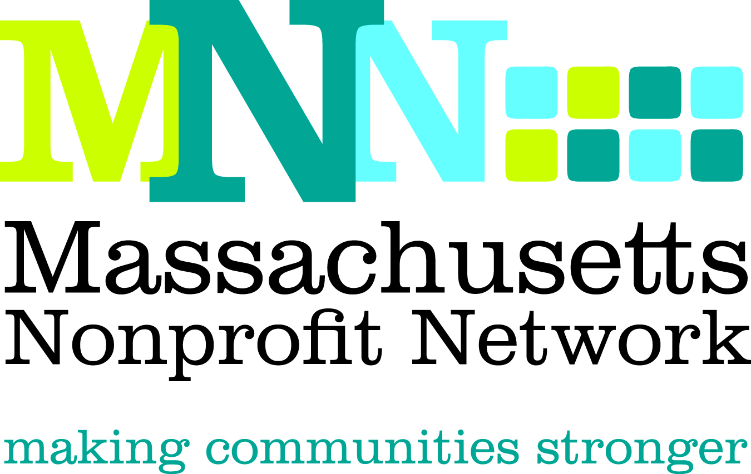

2012 Conference & Expo
Workshop RFP

We are pleased to invite you to submit a workshop proposal for our annual conference, which will be held on Thursday, October 25 at the Best Western Royal Plaza and Trade Center in Marlborough, MA.

While nonprofits have been confronted with a rapidly changing landscape fueled by economic restructuring and dynamic technology, these changes have also fueled new strategies and approaches resulting in increased efficiency and effectiveness. At this year’s conference, we want to share the approaches that nonprofit organizations have developed to succeed in this new landscape.
We are seeking proposals for workshops that focus on strategies and innovative responses to advances in technology, societal problems, economic uncertainty, funding changes, and other changes in the nonprofit landscape. We are seeking proposals that will enable our participants to leave the conference re-energized with new information, skills and strategies that they can use to help them to survive and thrive despite the uncertainty of our recent times.
Please make sure that your proposal is complete and adheres to the word limits to ensure full consideration by the Selection Committee.

Workshops will be 90 minutes long. There will be three workshop blocks throughout the day, and high demand workshops may be held more than once, so we ask that presenters be available for the whole day. Presenters are welcome to attend the workshop of their choice when they are not presenting, as well as the main sessions. Breakfast and lunch are also included.

The deadline for all proposals is March 14, 2012. Please email all completed proposals to conference@massnonprofitnet.org and include the words “Workshop RFP” in the subject line.

Please note that stipends are not available for facilitating a workshop. Presenters will be responsible for providing their own laptop and handouts; projectors will be provided on request.

Judging Criteria
- Clear and compelling title
- Relevance to the topics outlined in the two above paragraphs
- Description outlines engaging workshop with valuable and relevant content
- Demand for topic (based on previous attendance and evaluation results)
- Format is appropriate for content and can be done effectively in allotted time
- Experience and expertise level of presenter(s)
- Overall quality of workshop and learning outcomes
- References

Successful proposals will:
- Provide attendees with current information on emerging best practices and/or technologies
- Offer concrete solutions and/or steps people can take-away
- Provide insight and/or greater understanding of trends or changes impacting the sector
- Clearly demonstrate how the presentation will be interactive and informative
- Present a plan for knowledge sharing that fits within the time allotted

If you have any questions, please contact Thea Edwards at tedwards@massnonprofitnet.org or 617-330-1188 x280.

Main Contact Information:
The main contact will receive all workshop-related communications and will be responsible for communicating this information to their co-presenters, as necessary.
Name:
Organization:
Email Address:
Website:
Phone Number:
Address:
City:
State:
Zip:

Number of presenters: (may not exceed two, unless panel format)

Please list name, organizational affiliation, and email address for all presenters:
If you have more than two presenters, please list their contact information under the last question on the form.

Presenter 1
Name:
Organization:
Email address:
Website:
Phone Number:
Address:
City:
State:
Zip:

Presenter
Name:
Organization:
Email address:
Website:
Phone Number:
Address:
City:
State:
Zip:

Please provide a brief bio for all presenters.* (maximum of 100 words, to include bios of all presenters)
Please note that these bios will be used in informational and promotional materials, if selected.

Workshop Title:

Category: (please select one)
Please note that the bullets under each category give examples of some topics that may be addressed, but are not all-inclusive.
- Reaching Target Audiences
  - Communications
  - Marketing
  - Advocacy
  - Increasing public awareness and engagement
  - Reaching and engaging hard to engage prospective clients
- Organizational Development
  - Organizational structure
  - Use of data and metrics
  - Board roles and engagement
  - Program assessment and development
  - Public/private partnerships
  - Nonprofit collaborations/partnerships
  - Leadership development
- Resource Development & Fundraising
  - Sources of funding
  - Responding to changing funder/grantee relationships
  - Earned Income
  - Use of technology
  - Board engagement
  - Finding new prospects
- Organizational Operations
  - Managing human resources, including volunteers
  - Staffing solutions and structures
  - Outsourcing and resource sharing
  - Financial management
  - New technologies

Please give a brief synopsis of your workshop. (200 word limit)
Please note that this synopsis may be used as a foundation for workshop description in informational and promotional materials, if selected.*

Format: (please select one)
- Experiential Training
- Open Forum/Discussion
- Presentation/Lecture
- Panel
- Other, please describe:

Level: (please select one)
- Introductory (for attendees with little knowledge or experience/focuses on basics or broad overviews)
- Intermediate (for attendees with some knowledge or experience/focuses on building on a basic foundation to strengthen skills)
- Advanced (for attendees with extensive knowledge and/or experience/focuses on presenting new or innovative trends and strategies and/or requires a high level of previous knowledge)

This workshop is geared toward: (please select one)
- Small organizations (less than 10 full-time employees)
- Mid-sized organizations (10-50 full-time employees)
- Large organizations (more than 50 full-time employees)
- Organizations of all sizes

Please describe your target audience, e.g. Executive Directors, human service providers, mid-career professionals, etc. (50 word limit)

What professional and organizational capacity-building skills, information, or knowledge will attendees take away? (150 word limit)

Is there a limit to the number of registrants your workshop can accommodate? If so, please explain what this limits are and why they are needed. (50 word limit)
Please note that MNN may not be able to impose registration caps on high-demand workshops.

How does your workshop illustrate the purpose of the conference as outlined in the italicized opening paragraphs of the RFP? (150 word limit)

If selected, would you be willing to share your presentation and materials with all conference attendees following the conference? Since many conference attendees cannot attend all of the workshops that interest them, our goal is to provide them with a password-protected website where they can access workshop materials and presentations post conference.
- Yes
- No

Is there anything else you would like to share with us about your workshop, presenters, format, or experience? (150 word limit)

Have you presented or facilitated on this topic in the past? If so, please list where and when:

References:
Please choose references who can speak to your abilities and experience as a presenter.
Reference 1
Name:
Relationship to you:
Email address:
Phone:

Reference 2
Name:
Relationship to you:
Email address:
Phone:

Reference 3
Name:
Relationship to you:
Email address:
Phone:

*Please note that MNN reserves the right to edit workshop descriptions and presenter bios to better fit the format of our informational and promotional materials.

