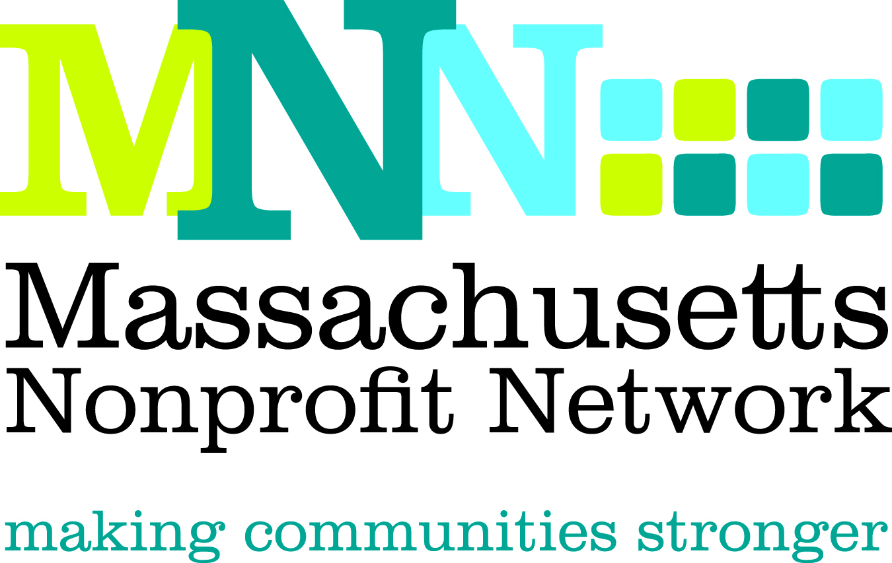

Excellence Award Nomination Form
Collaboration

Thank you for nominating an organization for the 2012 MNN Excellence Award in Collaboration. Please complete the questions below. Incomplete nominations and nominations that do not adhere to word limits may not be eligible for judging. Please note that an organization must be a 501(c)3 located in Massachusetts to be considered for this award.

The deadline for all nominations is March 28, 2012. Please email all completed nominations to Thea Edwards at tedwards@massnonprofitnet.org and include “Collaboration Nomination” in the subject line.

The Excellence Award in Collaboration recognizes two or more nonprofit organizations that have partnered to achieve an outcome that furthers the mission of each organization and could not have been achieved separately.
Judging Criteria
- Identified a pressing need that could only be addressed collaboratively
- Collaboration demonstrated effective allocation and use of combined resources in a way that furthered the missions of all involved organizations
- Achieved meaningful and measureable outcomes that were amplified through collaborative efforts

If you have any questions, please contact Thea Edwards at tedwards@massnonprofitnet.org or 617-330-1188 x280.

Nominator Contact Information: (Please leave blank if self-nominating.)
Name:
Email Address:
Phone Number:

Nominee Contact Information: (Please choose one contact from the lead organization to be the main contact)
Contact Name:
Email Address:
Phone:

Organization Information: (Please choose one organization as the lead organization for contact purposes)
Organization:
Website:

Address:
City:
State:
Zip:

Collaborating Organization Information:
Organization:
Website:

Address:
City:
State:
Zip:

Please give brief descriptions of the collaborating organizations, including missions, size, dates established, and programs and services offered. (150 word limit)

Please share what motivated you to nominate these organizations and why you believe these organizations are the best candidates for this award. (150 word limit)
Please briefly describe the need or issue addressed and why it was best addressed through collaborative efforts. (200 word limit)

With the judging criteria in mind, please describe, using concrete examples, the work these organizations have collaboratively undertaken that would qualify them for this award. (150 word limit)
Please provide a clear description of the outcomes achieved in this area and how the actions described above lead to these outcomes. (150 word limit)

