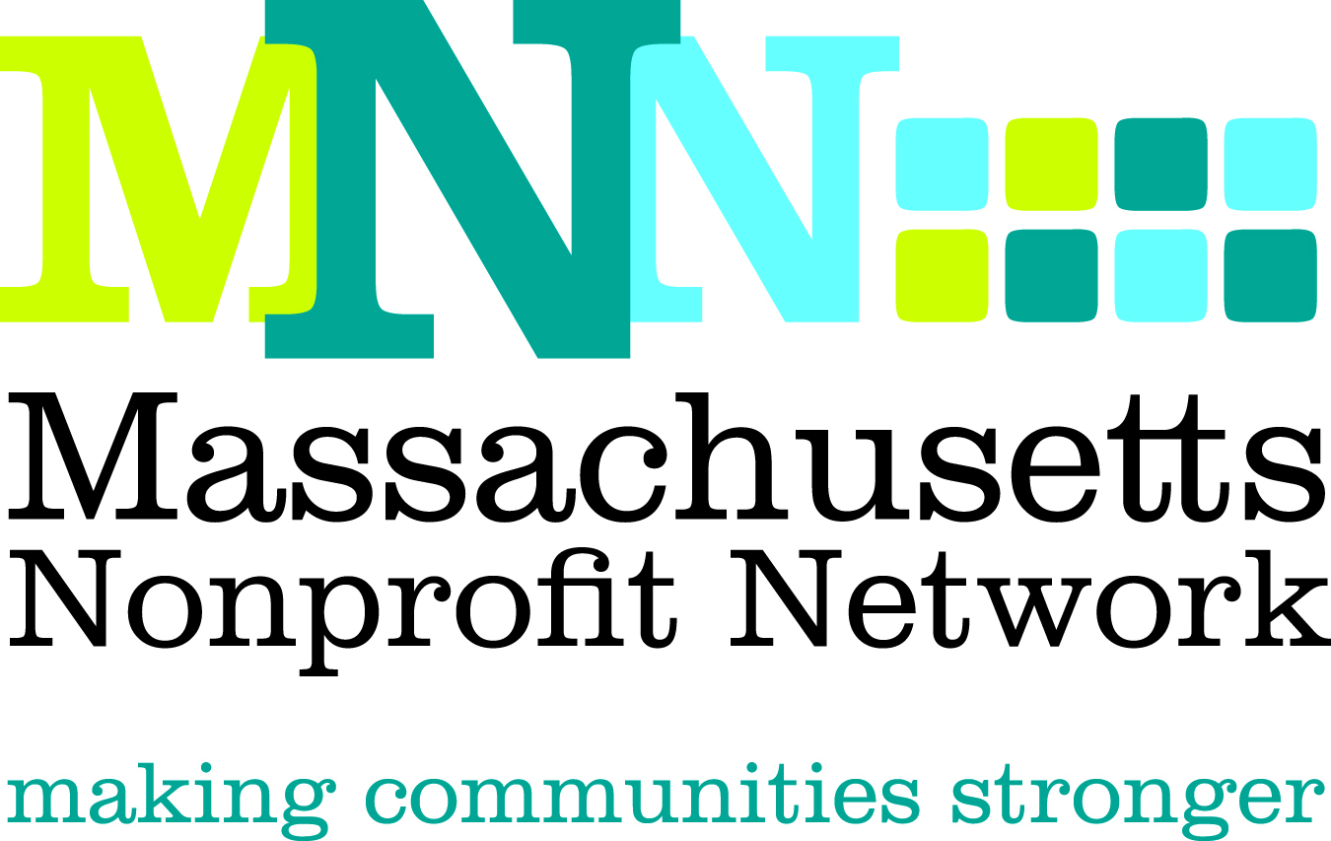

Excellence Award Nomination Form
Board Leadership

Thank you for nominating an organization for the 2012 MNN Excellence Award in Board Leadership. Please complete the questions below. Incomplete nominations and nominations that do not adhere to word limits may not be eligible for judging. Please note that an organization must be a 501(c)3 located in Massachusetts to be considered for this award.

The deadline for all nominations is March 28, 2012. Please email all completed nominations to Thea Edwards at tedwards@massnonprofitnet.org and include “Board Leadership Nomination” in the subject line.

The Excellence Award in Board Leadership recognizes a nonprofit organization that exemplifies best practice in board governance and effectively partners with staff resulting in improved outcomes and/or increased resources.
Judging Criteria
- Board has effectively worked with staff to identify strategic direction and to create a plan to strengthen the organization
- Board is involved, effective, and informed
- Board has effectively assisted in increasing resources to meet strategic organizational goals, resulting in meaningful and measurable outcomes

If you have any questions, please contact Thea Edwards at tedwards@massnonprofitnet.org or 617-330-1188 x280.

Nominator Contact Information: (Please leave blank if self-nominating.)
Name:
Email Address:
Phone Number:

Nominee Contact Information:
Contact Name:
Email Address:
Phone:

Organization Information:
Organization:

Website:

Address:
City:
State:
Zip:

Please give a brief description of the organization, including mission, size, date established, and programs and services offered. (150 word limit)

Please share what motivated you to nominate this organization and why you believe this organization is the best candidate for this award. (150 word limit)
Please briefly describe the challenges or strategic initiatives that this board undertook. (150 word limit)

With the judging criteria in mind, please describe, using concrete examples, the work this organization’s board has done that would qualify it for this award. (200 word limit)
Please provide a clear description of the outcomes achieved in this area and how the actions described above lead to these outcomes. (150 word limit)

