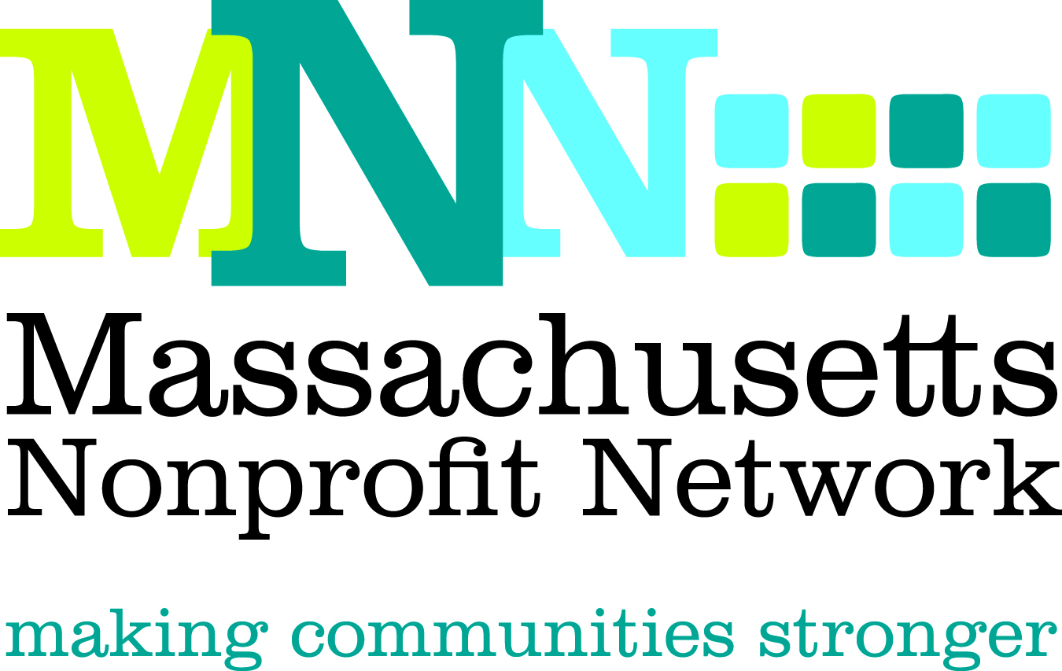

Excellence Award Nomination Form
Advocacy

Thank you for nominating an organization for the 2012 MNN Excellence Award in Advocacy. Please complete the questions below. Incomplete nominations and nominations that do not adhere to word limits may not be eligible for judging. Please note that an organization must be a 501(c)3 located in Massachusetts to be considered for this award.

The deadline for all nominations is March 28, 2012. Please email all completed nominations to Thea Edwards at tedwards@massnonprofitnet.org and include “Advocacy Nomination” in the subject line.

The Excellence Award in Advocacy recognizes a nonprofit organization whose work has affected significant public policy change through the education and mobilization of constituents, the general public, and/or public policy decision makers.
Judging Criteria
- Created a compelling and successful advocacy campaign in response to a pressing need
- Engaged constituents, the general public, and/or public policy decision makers in a meaningful way throughout the advocacy process
- Achieved meaningful and measurable outcomes

If you have any questions, please contact Thea Edwards at tedwards@massnonprofitnet.org or 617-330-1188 x280.

Nominator Contact Information: (Please leave blank if self-nominating.)
Name:
Email Address:
Phone Number:

Nominee Contact Information:
Contact Name:
Email Address:
Phone:

Organization Information:
Organization:
Website:

Address:
City:
State:
Zip:

Please give a brief description of the organization, including mission, size, date established, and programs and services offered. (150 word limit)

Please share what motivated you to nominate this organization and why you believe this organization is the best candidate for this award. (150 word limit)
Please briefly explain the need or issue addressed by this campaign and why this advocacy initiative was the best way to address this issue. (150 word limit)
With the judging criteria in mind, please describe, using concrete examples, the work this organization has done that would qualify it for this award. (200 word limit)
Please provide a clear description of the outcomes achieved in this area and how the actions described above lead to these outcomes. (150 word limit)

