**Silvio O. Conte Federal Building**

**78 Center Street, Pittsfield, MA 01201**



**MAP**

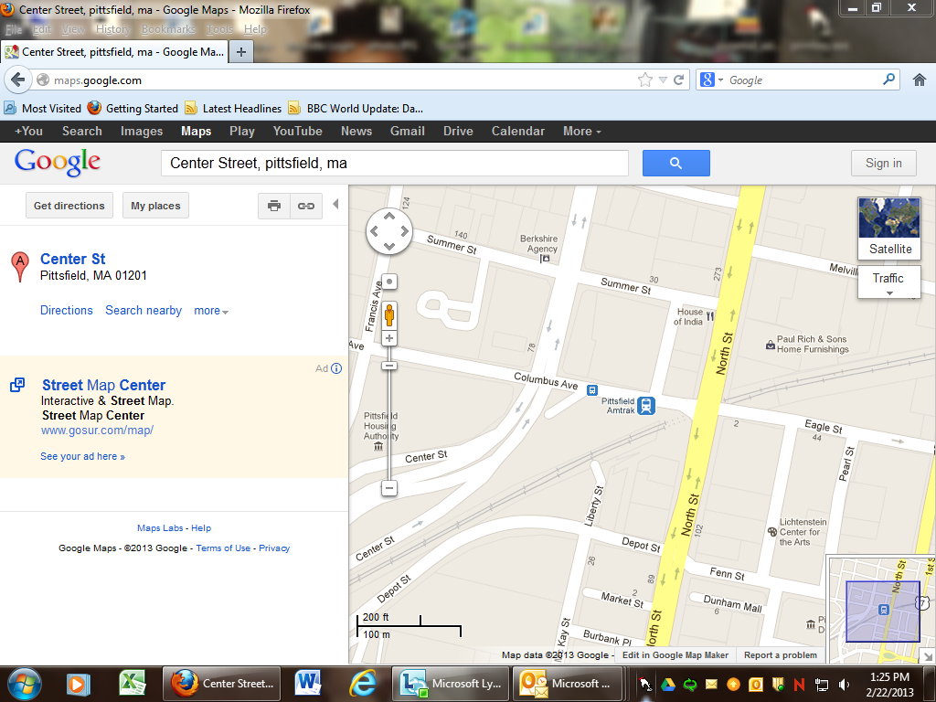

Park here at the Columbus Avenue Parking garage – top level

Massachusetts Nonprofit Network Mtg, room 204A

Conte Federal

Building

Parking garage